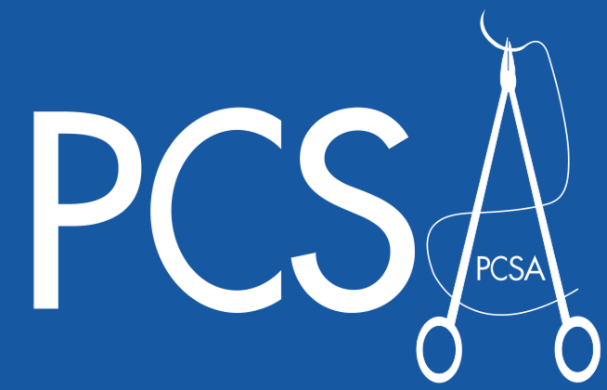 ROSS ARDILL AUDIT & RESEARCH PRIZE
The Primary Care Surgical Association invites submissions (abstract) for the Prize (€500 oral, €200 poster) on any topic relating to surgical, dermatological, orthopaedic, ENT or similar procedures in primary care. All shortlisted presenters will have free registration at the conference on November 11th&12th in Limerick. Enquiries before Oct 15th to Dr Kieran McCabe, Secretary at PCSA.Ireland@gmail.com. See conference details at www.pcsa.ie
Open to GP Trainees, Practice nurses, GPs and all community-based surgeons.

2022

